**Reg No : 192211289**

**Name: S.Kanishma**

**DAY 02 – FUNDAMENTALS OF COMPUTING**

17.

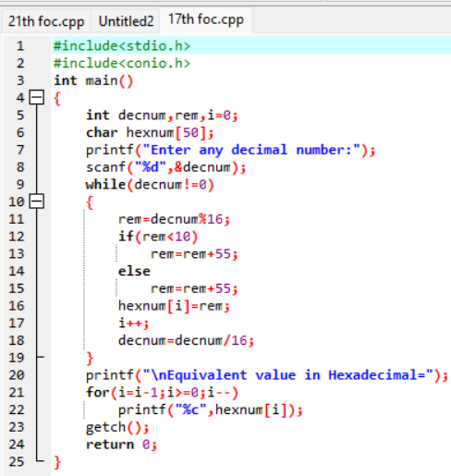

OUTPUT:

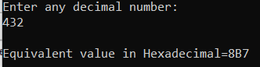

21.

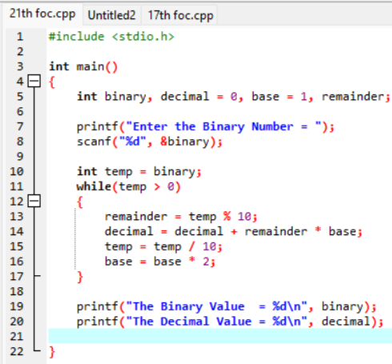

OUTPUT:

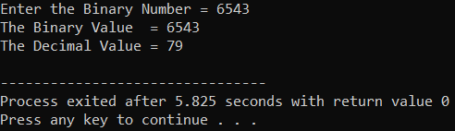

19.

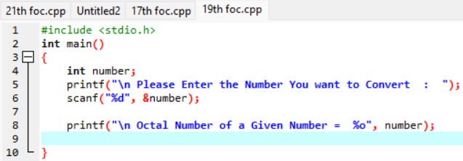

OUTPUT:

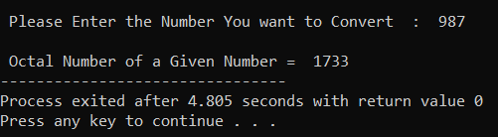

20.

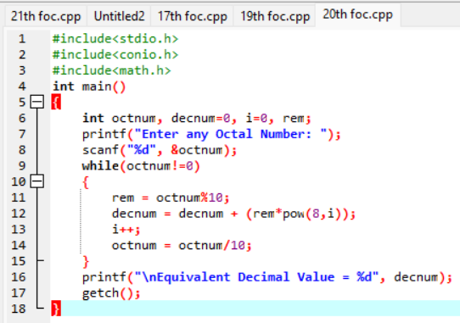

OUTPUT:

